Field Epidemiology Training Programme (FETP), India.

Designing effective graphs

The seven steps to follow for an effective graph

Identify the points that will benefit from a graph
The report should contain no more than five tables and or figures. Ask yourself whether the point you want to make will be better served by a graph (analogical communication making an overall point) or by a table (digital information providing exhaustive details).

Frame the message you want to get across in your graph
Spell out the message the graph will be communicating. Identify all the data that need to be included. Exclude the data that do not contribute to the main message. The message should be clear and concise: For example: “Measles incidence decreased by half between … and … in [location]”. If there is nothing to say (the incidence is stable), a sentence might be sufficient unless this is a point you really want to underline (e.g., your control programme aimed at a decrease and there is no decrease). Do not duplicate the information between the text and the tables.

Decide which graph is most adapted to your message
Use Figure 1 to identify the type of graph that will be most adapted to the data you want to present and the message you want to communicate.

Draw your graph in a spreadsheet
Know what you want to do and do it. If you can’t do it, ask for assistance. Don’t let the spreadsheet decide for you.

Optimize the ink-to-data ratio
Get rid of the unnecessary stuff, including:
  - The gridlines;
  - The frame (for the graph and the legend);
  - The background;
  - The Y axis for horizontal bar charts;
  - The data labels.

Chose your colours
You choose the colours, it is not excel that choose them for you. The combination of colours must serve your message.

Test, have other review and modify
Show your graph to others and see if they get your point. If they don’t, modify. Remember: It is the main message that drives the way your graph must be.

Figure 1: Flow chart to identify the type of graph that is adapted to your message

Example 1: Epidemic curve

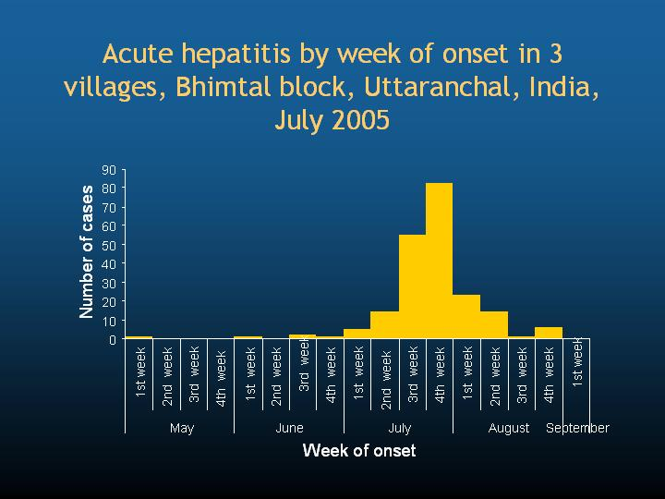
Example 2: Time series

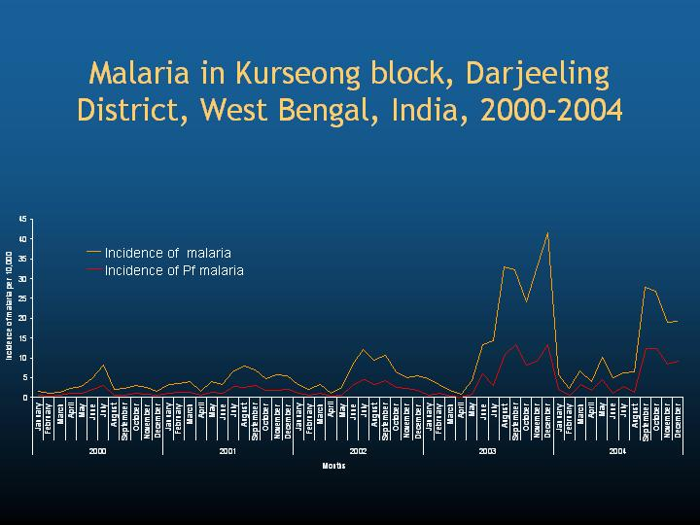
Example 3: Histogramme

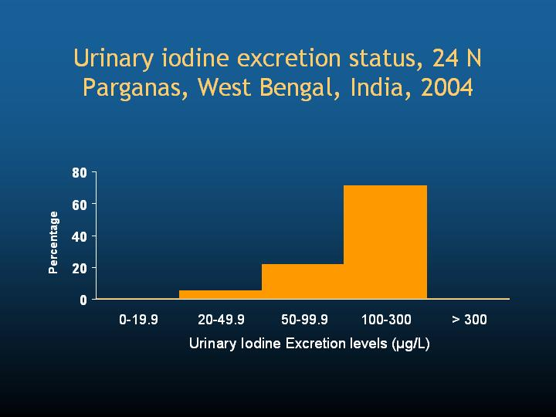
Example 4: Pie chart

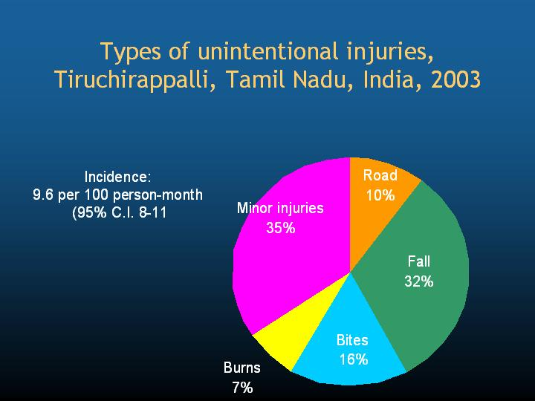
Example 5: Juxtaposed bars

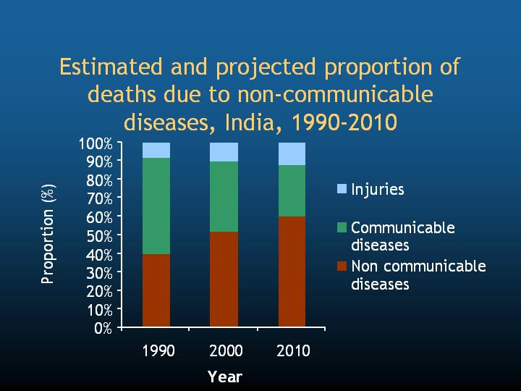

Example 6: Vertical bars

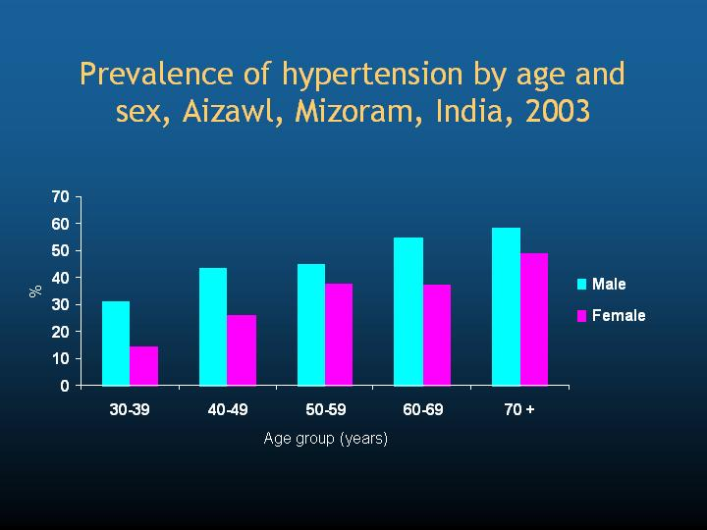
Example 7: Horizontal bars

