Case study:
An outbreak of diarrhea in Parbatia, Orissa, India (Part 1)
2-week course for District Surveillance Officers, India
Version 3.2 - Revised after pilot testing
Case study developed for the training of the district surveillance officers of the Indian Integrated Disease Surveillance Programme (IDSP). It is inspired by an investigation conducted by Dr Amitav Das, 2003 scholar of the Master of Applied Epidemiology (MAE) - Field Epidemiology Training Programme (FETP) from the National Institute of Epidemiology (NIE), Indian Council of Medical Research (ICMR), Chennai, Tamil Nadu, India. Dr Das was an FETP scholar assigned to the State of Orissa at the time of the investigation.

Learning objectives
At the end of the case study, the participant will be able to:
- Review the steps of an outbreak investigation;
- Work with the laboratory to confirm the diagnosis during an outbreak;
- Describe an outbreak in terms of time, place and person characteristics;
- Understand the principles of analytical epidemiology during an outbreak investigation;
- Formulate conclusions and recommendations;
- Communicate recommendations for action to the relevant target groups;
- Write a report;
- Work with other sectors to ensure the implementation of the recommendations.

Use of computer tools (word processors, spreadsheet) will be encouraged during the case study so that participants can become more familiar with them.

Note: While the story supporting this case study is a cholera outbreak, this case study does focus on cholera-specific issues but on general principles in outbreak detection and response.

Using this case study in a class

Duration and organization
This case study is divided in eight parts of two hours each organized so that (1) each part is done following the corresponding classroom activities and that (2) the case study is spread over the duration of a whole week.

Learning approach
This is designed as a stand-alone case study and does not come with a facilitator’s guide. The answers to all the questions in each section are provided as an introduction to the following section. To run this case study in a class, it is proposed to distribute it one part at a time. Participants take turns reading it out loud, paragraph by paragraph. Reading everything out loud and in turns has two advantages. First, everyone can quickly participate and go beyond the inhibition of having her/his voice heard in a large room. Second, time is given to the whole class to understand the issue and think about the answers. The participant reading the question may try to answer it if s/he can propose an answer. Otherwise, the matter is discussed as a group. The next participant reads the next question and so on until the end of the page. After distributing the next part, participants continue reading the text in that manner until the case study is over. Once the epilogue has been read, it is proposed to go back to the first page to read the objectives again. This re-iterates the learning and provides additional clarification opportunities.

Part 1: A cluster of acute diarrhea in Parbatia, Orissa (2 hours)

On 14 November 2003, a health care worker from a sub-centre in the village of Parbatia reported to a primary health centre (PHC) from the district of Dhenkanal, state of Orissa a cluster of five cases of acute, severe diarrhea with dehydration among adults in his village (no deaths, Figure 1). The PHC forwarded the report to the district. The cluster seemed to have started with a single case, with secondary spread. The population of the village in 2003 was 946. The diagnosis of cholera was suspected. Health care workers locally heavily chlorinated the wells in the village and called for assistance. On 15 November 2003, an epidemiologist in training assigned to the state of Orissa initiated an investigation and arrived in the village in the morning.

Question 1.A
What processes do you use in your district for rumour/ outbreak verification?

Question 1.B
What should be done in this specific situation to determine whether this is an outbreak or not? What information would you need?

Question 1.C
What is the key administrative step that must be taken to send the alert? Work by group to take necessary action using the template that applies.

Question 1.D
What kind of team needs to be constituted to investigate this outbreak?
Figure 1: Map of Parbatia village, Orissa, 2003
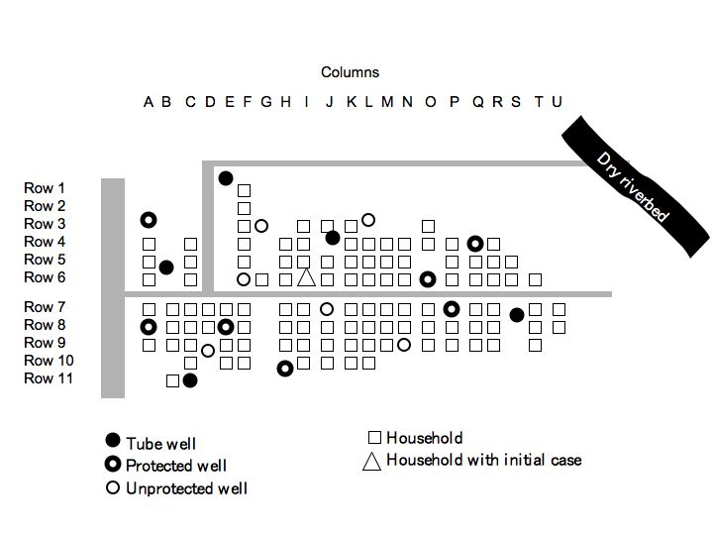

Box 1: First Information Report [FIR] form.
FIRST INFORMATION REPORT FORM – FORM C
Officer In Charge CHC/PHC – Trigger-1 Response:
General information
State:
District:
Town / PHC:
Ward / Village:
Population:
District code No:
Background information
Person reporting the outbreak:
Date of report:
Date investigations started:
Person(s) investigating the outbreak:
Details of investigation
Describe how the cases were found (may include: (a) house-to- house searches in the affected area; (b) visiting blocks adjacent to the affected households; (c) conducting record reviews at local hospitals; (d) requesting health workers to report similar cases in their areas, etc.):

Descriptive epidemiology
1. Cases by time, place and person (attach case based reporting forms and relevant graphs and maps).

2. Age-specific attack rates and mortality rates.
3. High-risk age groups and geographical areas.
Description of control measures taken.
Brief description of problems encountered:
Factors which, in your opinion, contributed to the outbreak.

Conclusions and recommendations

Each household can be located on this simplified map through its row and column coordinates (e.g., Household of initial case is Column I- Row 6)

