Part 4: Testing hypotheses through comparisons (2 hours)

First section
The results of the laboratory testing came back to confirm the diagnosis of cholera (Vibrio cholerae O1, biotype El-tor, serotype Ogawa). The description of the epidemic curve (Figure 1) indicated that there was an initial case with a date of onset on 10 November. Then, there was an increase in the number of cases followed by a slower decrease. As an interpretation, the investigators suspected a common source outbreak (with the initial case as a source case), although the second part of the epidemic curve stretched to the right could also suggest secondary person-to-person transmission, at least for the second part of the outbreak.
Figure 1: Cases of cholera by date of onset, Parbatia, Orissa, India, November 2003
The attack rate was high among adults, which was compatible with the diagnosis of cholera (Table 1).
Table 1: Attack rates of cholera by age and sex, Parbatia, Orissa, India, 2003
 |  | Number of cases | Population | Incidence
Age group  (In years) | 0 to 4 | 6 | 113 | 5%
Age group  (In years) | 5 to 14 | 4 | 190 | 2%
Age group  (In years) | 15 to 24 | 5 | 128 | 4%
Age group  (In years) | 25 to 34 | 5 | 144 | 3%
Age group  (In years) | 35 to 44 | 6 | 129 | 5%
Age group  (In years) | 45 to 54 | 4 | 88 | 4%
Age group  (In years) | 55 to 64 | 8 | 67 | 12%
Age group  (In years) | 65 and + | 3 | 87 | 3%
Sex | Male | 17 | 481 | 3%
Sex | Female | 24 | 465 | 5%
Total | Total | 41 | 946 | 4%

Most cases were clustered around an unprotected well located close to the residence of the initial case-patient. Hypothesis generating interviews with this index case-patient indicated that this person fell sick and soiled her clothes with diarrhea. Thus, she left her house (shown with a triangle on the map) and crossed the road to the unprotected well (Figure 2) to wash her soiled clothes there.

Figure 2: Cholera cases by residence, Parbatia, Orissa, India, November 2003
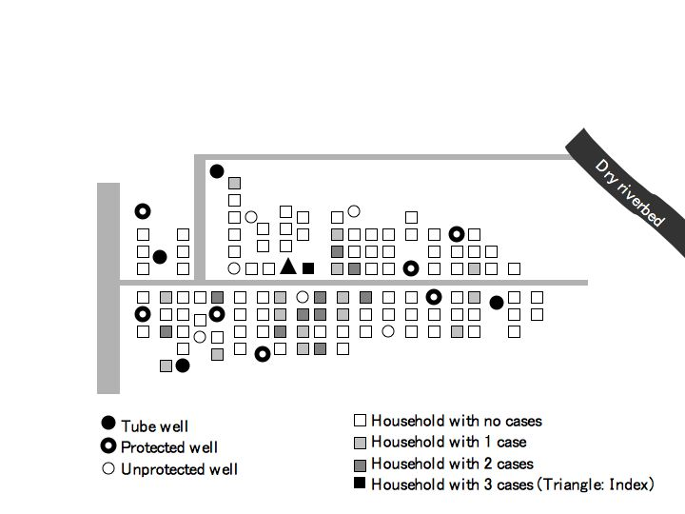
On the basis of the description of the outbreak by time, place and persons and the hypothesis generating interviews, the investigators suspected that the initial case patient had contaminated the well while washing her clothes when she was sick and that the contamination of the well led to a common source outbreak, maybe with a certain degree of subsequent person-to-person transmission. The well in question was unprotected with no brim and no platform. Most case-patients were drinking water from that well.
Figure 3: The well where the initial case-patient came to wash clothes, Parbatia, Orissa, India, 2003
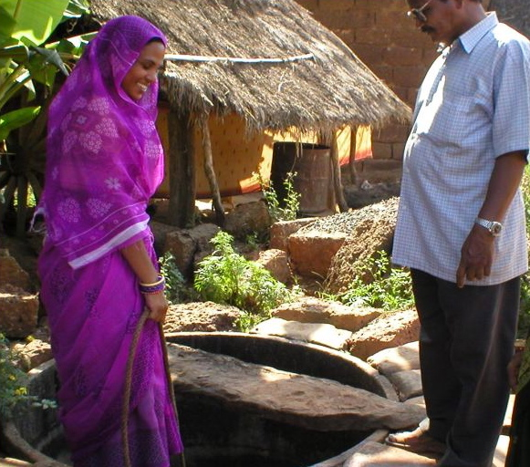

Question 4.A
Is the information collected so far sufficient to incriminate the well in this outbreak?

Question 4.B
What additional piece of epidemiological evidence would strengthen the evidence?

Second section
While the descriptive epidemiology pointed to the well as the source of the outbreak, the epidemiologist decided to strengthen his investigation with an analytical study. He decided to compare each case of cholera with two unaffected neighbours in terms of the proportion of persons who drank water from the suspected well. The idea is that if the well is indeed the source of the outbreak, then a higher proportion of case-patients than unaffected neighbours should have drunk water from the well. The epidemiologist collected information regarding 40 cholera cases and 80 unaffected neighbours of similar age and sex (Table 2). The initial case was excluded from this analysis, because since this case-patient is suspected to be the source of infection, she could not have acquired the disease from herself.

Question 4.C
Compile the data on Table 2 to compare case patients and healthy villagers in terms of drinking water from the suspected well. What does this tell you? (Tip: It may be useful to construct a two by two table to break down cases and non cases according to their water consumption habits)

Question 4.D
Compile the data on Table 2 to compare case patients and healthy villagers in terms of eating food from outside of the villager. What does this tell you? (Tip: It may be useful to construct a two by two table to break down cases and non cases according to their food consumption habits)

Table 2: Line listing of unaffected neighbours, Parbatia village, Orissa, India, November 2003

ID | Age (Years) | Sex | Taken food outside village | Drinking water from the well used by the initial case-patient
1 | 21 | M | No | No
2 | 20 | M | No | No
3 | 27 | F | No | No
4 | 26 | F | No | No
5 | 77 | M | No | Yes
6 | 74 | M | No | Yes
7 | 60 | M | No | Yes
8 | 62 | M | No | Yes
9 | 55 | F | No | Yes
10 | 55 | F | No | Yes
11 | 37 | M | No | Yes
12 | 35 | M | No | Yes
13 | 36 | M | No | No
14 | 35 | M | No | No
15 | 23 | F | No | No
16 | 20 | F | No | No
17 | 16 | M | No | No
18 | 16 | M | No | No
19 | 1.5 | F | No | No
20 | 1.8 | F | No | No
21 | 26 | M | Yes | No
22 | 27 | M | No | Yes
23 | 42 | M | No | Yes
24 | 44 | M | Yes | Yes
25 | 3 | M | No | Yes
26 | 3.5 | M | No | Yes
27 | 23 | F | No | Yes
28 | 22 | F | No | Yes
29 | 27 | F | No | Yes
30 | 29 | F | No | Yes
31 | 3.8 | M | No | No
32 | 4 | M | No | No
33 | 46 | F | No | No
34 | 43 | F | No | No
35 | 34 | F | No | No
36 | 35 | F | No | No
37 | 61 | M | No | No
38 | 61 | M | No | No
39 | 64 | M | No | No
40 | 60 | M | No | No

ID | Age (Years) | Sex | Taken food outside village | Drinking water from the well used by the initial case-patient
41 | 55 | F | No | No
42 | 56 | F | No | No
43 | 55 | F | No | No
44 | 55 | F | No | Yes
45 | 53 | F | No | No
46 | 51 | F | No | No
47 | 13 | F | No | Yes
48 | 12 | F | No | Yes
49 | 16 | F | No | No
50 | 15 | F | No | No
51 | 35 | F | No | No
52 | 37 | F | No | No
53 | 71 | F | No | No
54 | 68 | F | No | No
55 | 1 | F | No | No
56 | 1 | F | No | No
57 | 19 | F | No | Yes
58 | 22 | F | No | No
59 | 13 | M | No | No
60 | 15 | M | No | No
61 | 74 | M | No | No
62 | 77 | M | No | No
63 | 33 | F | No | No
64 | 30 | F | No | No
65 | 52 | F | No | No
66 | 53 | F | No | No
67 | 1 | M | No | No
68 | 1 | M | No | No
69 | 35 | F | No | No
70 | 37 | F | No | No
71 | 53 | F | No | No
72 | 50 | F | No | No
73 | 0 | F | No | No
74 | 1 | F | No | No
75 | 62 | M | No | No
76 | 58 | M | No | Yes
77 | 5 | M | No | No
78 | 6 | M | No | No
79 | 67 | M | No | No
80 | 64 | M | No | Yes

