Part 8: Working with other sectors (2 hours)
The epidemiologist has completed a high level outline of the report (Box 1) for further expansion into a full report of less than 10 pages. He must now work with the rural engineering department to implement the recommendations agreed upon.

Question 8.A
Divide the class in two groups: Health sector and rural engineering department. For each group, list:
- Your concern in this issue;
- What could be the concern of the other group in this issue;
- What would you like to obtain from the other group.

Question 8.B
Debrief your results across groups and come to a consensus.

Question 8.C
On the basis of this exercise, what is the best strategy to approach the rural engineering department to make sure the recommendations will be implemented?

Box 1: High-level outline of the investigation report

Parbatia cholera outbreak investigation report (Orissa, 2003)

Background
- On 14 November 2003, village health workers informed of a cluster of diarrhea with dehydration among adults in Parbatia village, Denkhanal district, Orissa
- On 15 November 2003, the rapid response team initiated the investigation

Methods

Epidemiological methods
- We used WHO cholera case definition
- We searched for cases door to door in the village
- We compared the current rates to the background
- We described the outbreak by time, place and person
- We compared cases with unaffected neighbours with respect to the suspected exposure

Laboratory methods
- We collected rectal swabs for bacterial culture

Environmental investigations methods
- We examined the water sources in the village

Results

Epidemiological methods
- Rates of acute diarrhea were in clear excess of the background in the village
- We identified 41 cases and no death (attack rate: 4.3%)
- There was an initial cluster on 10 November followed by a peak around 15 November and possible secondary spread. The last case occurred on 21 November.
- Cases were clustered around a well where an initial case patient washed her soiled clothes.
- Attack rates were highest among older adults
- 80% of the 40 cases had drunk water from the well compared with 30% of non-cases.

Laboratory methods
- Rectal swab grew Vibrio Cholera O1 biotype El tor

Environmental investigations methods
- The well that caused the outbreak was unprotected, without any brim or platform

Conclusions
- A cholera outbreak affected Parbatia village. The most likely source was an unprotected well that had been contaminated by an initial source patient who had washed her soiled clothes in it.

Recommendations
- We barred access to the suspected well and disinfected it
- We educated the population about the risk associated with unhygienic use of wells
- The local government issued a note to forbid the washing of clothes in wells
- Plans are under way to protect the well that caused the outbreak with a brim and a platform

Annexes
- Epidemic curve, spot map, table of incidence by age and sex, photo of the well and case/ neighbour table

Epilogue
After a review of potential inter-sector collaboration issues (Table 1), the incriminated well was protected few months after the outbreak and new wells in the district were being constructed with protections (Figure 1).
Table 1: Issues in inter-sector collaboration, Parbatia, Orissa, 2003
Recommendations | Concerns of the public health department | Concerns of the rural engineering department | Proposed way forward
Warn that the well is dangerous | - The well is dangerous and should not be used. | - Pointing to the well may suggest rural engineering is to blame. | - Explain that the well became dangerous because it was not used properly.
Chlorinate the well | - The well is contaminated and must be disinfected. | - Well disinfection must take place according to a specific technical protocol. | - Engage rural engineering into conducting the disinfection as recommended.
Provide alternate water source | - Those who cannot use the well need water. | - Use of water sources in a village may follow a number of informal social rules that need to be respected. | - Engage rural engineering and the Panchayat so that the population can be directed to alternate water sources in a feasible way when the well is unusable.
Ban clothe washing in well | - Clothe washing caused the recent cholera outbreak. | - The rural engineering department cannot enforce such rule. | - Panchayat must enforce the ban of clothe washing in the wells.
Protect the well involved | - Lack of protection may have facilitated contamination. | - Due to limited resources, all unprotected wells cannot be protected at once. | - The well of the outbreak should be protected as a matter of priority.
Educate for safe use of wells | - Unsafe use of well expose to cholera. | - None. | - Both department need to promote safe use of wells in a coordinated manner.

Figure 1: The Parbatia outbreak well protected with a new platform and brim (left) and a new protected well constructed after the outbreak (right), Orissa, India, 2004
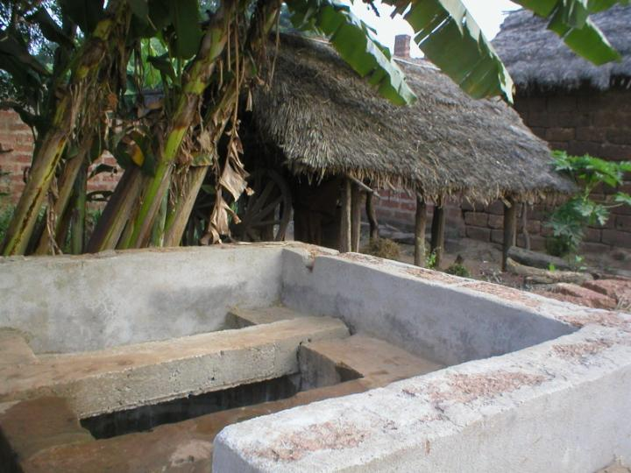 | 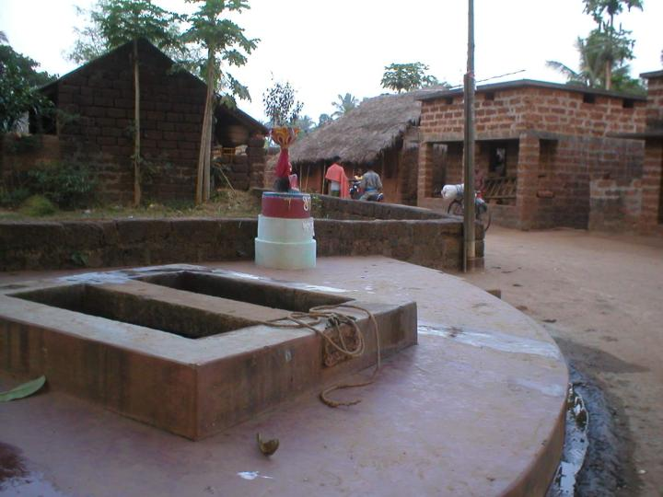
Although this case study only covered a cholera outbreak, you can use the skills and steps you learned in this exercise for the next outbreak you will encounter in your district, even if it is transmitted through a different route (e.g., vector borne) or prevented through the use of vaccine (e.g., measles). This will ensure than information will lead to action, as was the case for the Parbatia outbreak.

