Analyzing Chikungunya surveillance data in Kadapa district, Andhra Pradesh, India, 2006
A one-day learning workshop
Version 2.1 – 14 January 2008
Guide for the participants

Workshop developed on the basis of projects of the Master of Applied Epidemiology (MAE) - Field Epidemiology Training Programme (FETP) from the National Institute of Epidemiology (NIE), Indian Council of Medical Research (ICMR), Chennai, Tamilnadu, India. It is based upon the field exercise of the 2006 FETP cohort.

Pre-requisite:
This workshop was prepared to follow a lecture on surveillance data analysis and to prepare participants to their project on secondary analysis of surveillance data. Participants will be expected to be familiar with:
- Principles of public health surveillance;
- Data aggregation;
- Calculation of population-based incidence;
- Time, place and person analysis of epidemiological data.

Learning objectives
At the end of the workshop, the participant will be able to:
- Compile reported cases according to common characteristics;
- Prepare population denominator data to calculate of incidences;
- Calculate population-based incidences;
- Prepare a curve of incidence over time (“TIME analysis”);
- Draw a map of incidence by geographical area (“PLACE analysis”);
- Prepare a table of incidence by age and sex (“PERSON analysis”);
- Troubleshoot practical issues that arise while analyzing surveillance data.

Practical organization
This workshop is to be conducted over one day in small groups (4 or 5 persons) who will work independently but with the possibility to access facilitators for troubleshooting. Ideally, at least one computer should be available for each small group. Each small group receives a copy of this document and a set of surveillance data to analyze. Additional resources are available from facilitators upon request (A resource package is made available to them). The last session of the workshop will take place with the participation of the full class.

While the morning will be done as a classroom session, the afternoon will be spent with the assistance of computers.

Part 1: Data available at the district level (2 hours, classroom session)
Chikungunya is a debilitating viral illness caused by the Chikungunya virus that is spread by the bite of infected Aedes mosquitoes, primarily Aedes aegypti. The disease often presents itself with sudden onset of fever that may be accompanied by rigors. Joint pains then appear that are often incapacitating because of their severity. Bleedings and rash are also possible. Outbreaks of Chikungunya have been reported from Sub-Saharan Africa, India, Southeast Asia and the Philippines. They are usually explosive, with infection of a large proportion of the susceptible population within a few weeks. Prolonged evolutions are possible, with multiple peaks of incidence. The fever affects predominantly older age groups and women.

No Chikungunya outbreak has been reported in India since the 1980s. However, the virus re-emerged in the country in 2005, possibly through migrations through the Indian Ocean. A large outbreak of fever with joint pains affected several districts of the Indian states of Andhra Pradesh and Karnataka since December 2005. In February 2006, virological investigations confirmed the diagnosis of Chikungunya on the basis of serological diagnosis in a subset of patients. From December 2005 to March 2006, more than 9,000 cases had been reported in the state of Andhra Pradesh with attack rates ranging from 2.3 to 39% in villages. No deaths were reported.

In March 2006, the incoming 2006 class of the Indian Field Epidemiology Training Programme (FETP) of the National Institute of Epidemiology (NIE) decided to review the operations of the surveillance system in the state of Andhra Pradesh with a special emphasis on the district of Kadapa. They obtained surveillance data from health officials and decided to analyze them.

At the district level, the FETP scholars obtained a list summarizing the number of reported cases by village (See below). Working as small groups, review the data made available to you. Consider the points below:

Questions
- What kind of analysis can you conduct with the data available?
- What kind of analysis will you be unable to do with the data available?
- What additional information or other elements will you need? Ask your facilitators for the additional elements you may need!

Proposed tasks
Work as group and analyze the data given to you. Organize yourself to obtain the additional data you need. While we suggest that you compile the data by hand to prepare hardcopies with pens and pencils. Keep track of all the problems that you run into. Seek assistance from facilitators.

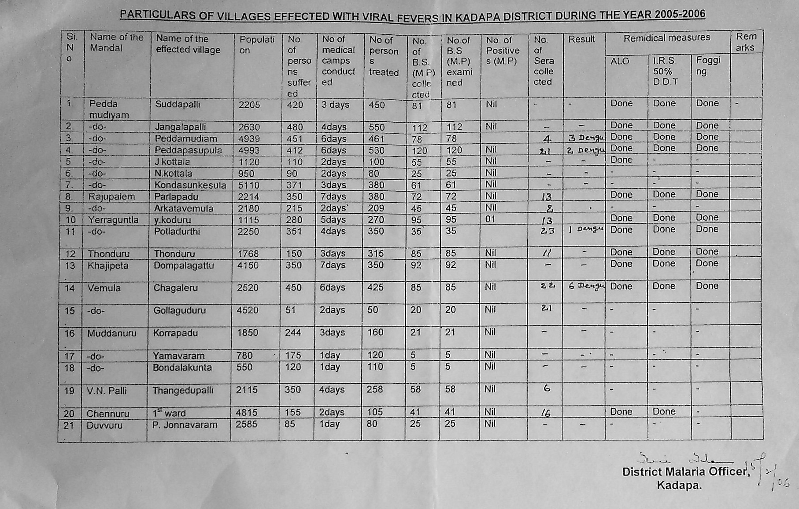
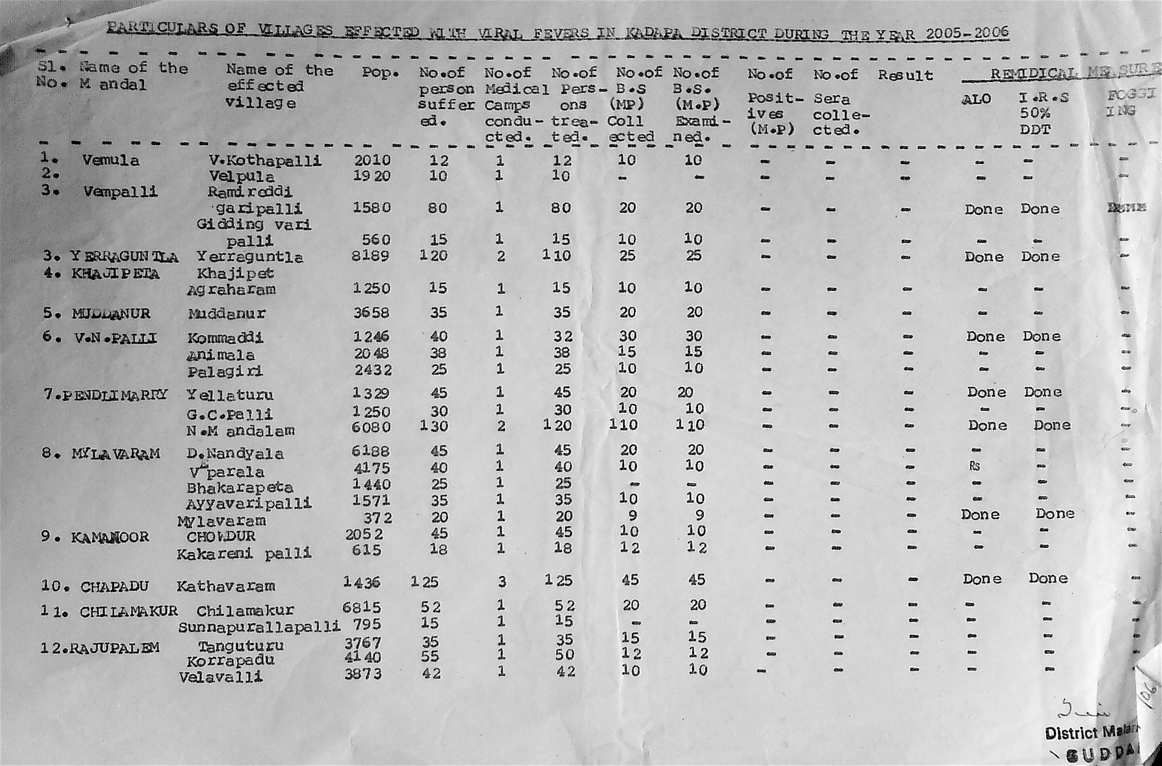

Part 2: Data available at the primary health care level (two hours, classroom session)
The data available at the district level allowed only describing the outbreak by geographical area. So at this stage, you should have a map of the Kadapa district showing the incidence by mandal. However, the data made available to you did not provide information on the incidence by person (age and sex) or over time (epicurve). This information is in fact “trapped” in the registers of the primary health centres that do not report individual cases when patient present themselves for care.

To get at least some idea on the dynamic of the outbreak in terms of time and person, in March 2006, the FETP team traveled to the primary health centre of Chennur (in Kadapa district). They gathered additional data in the form of a line listing of reported cases (See below). Continuing to working as small groups, review this new body of data and consider the points below:

Questions
- What kind of analysis can you conduct with the data?
- What additional information will you need?

Proposed tasks
Work as group and analyze the data given to you. Organize yourself to obtain additional data you may need. While we suggest that you compile the data by hand to prepare documents with paper and pens. Please keep track of all the problems that you run into. Seek assistance from facilitators.

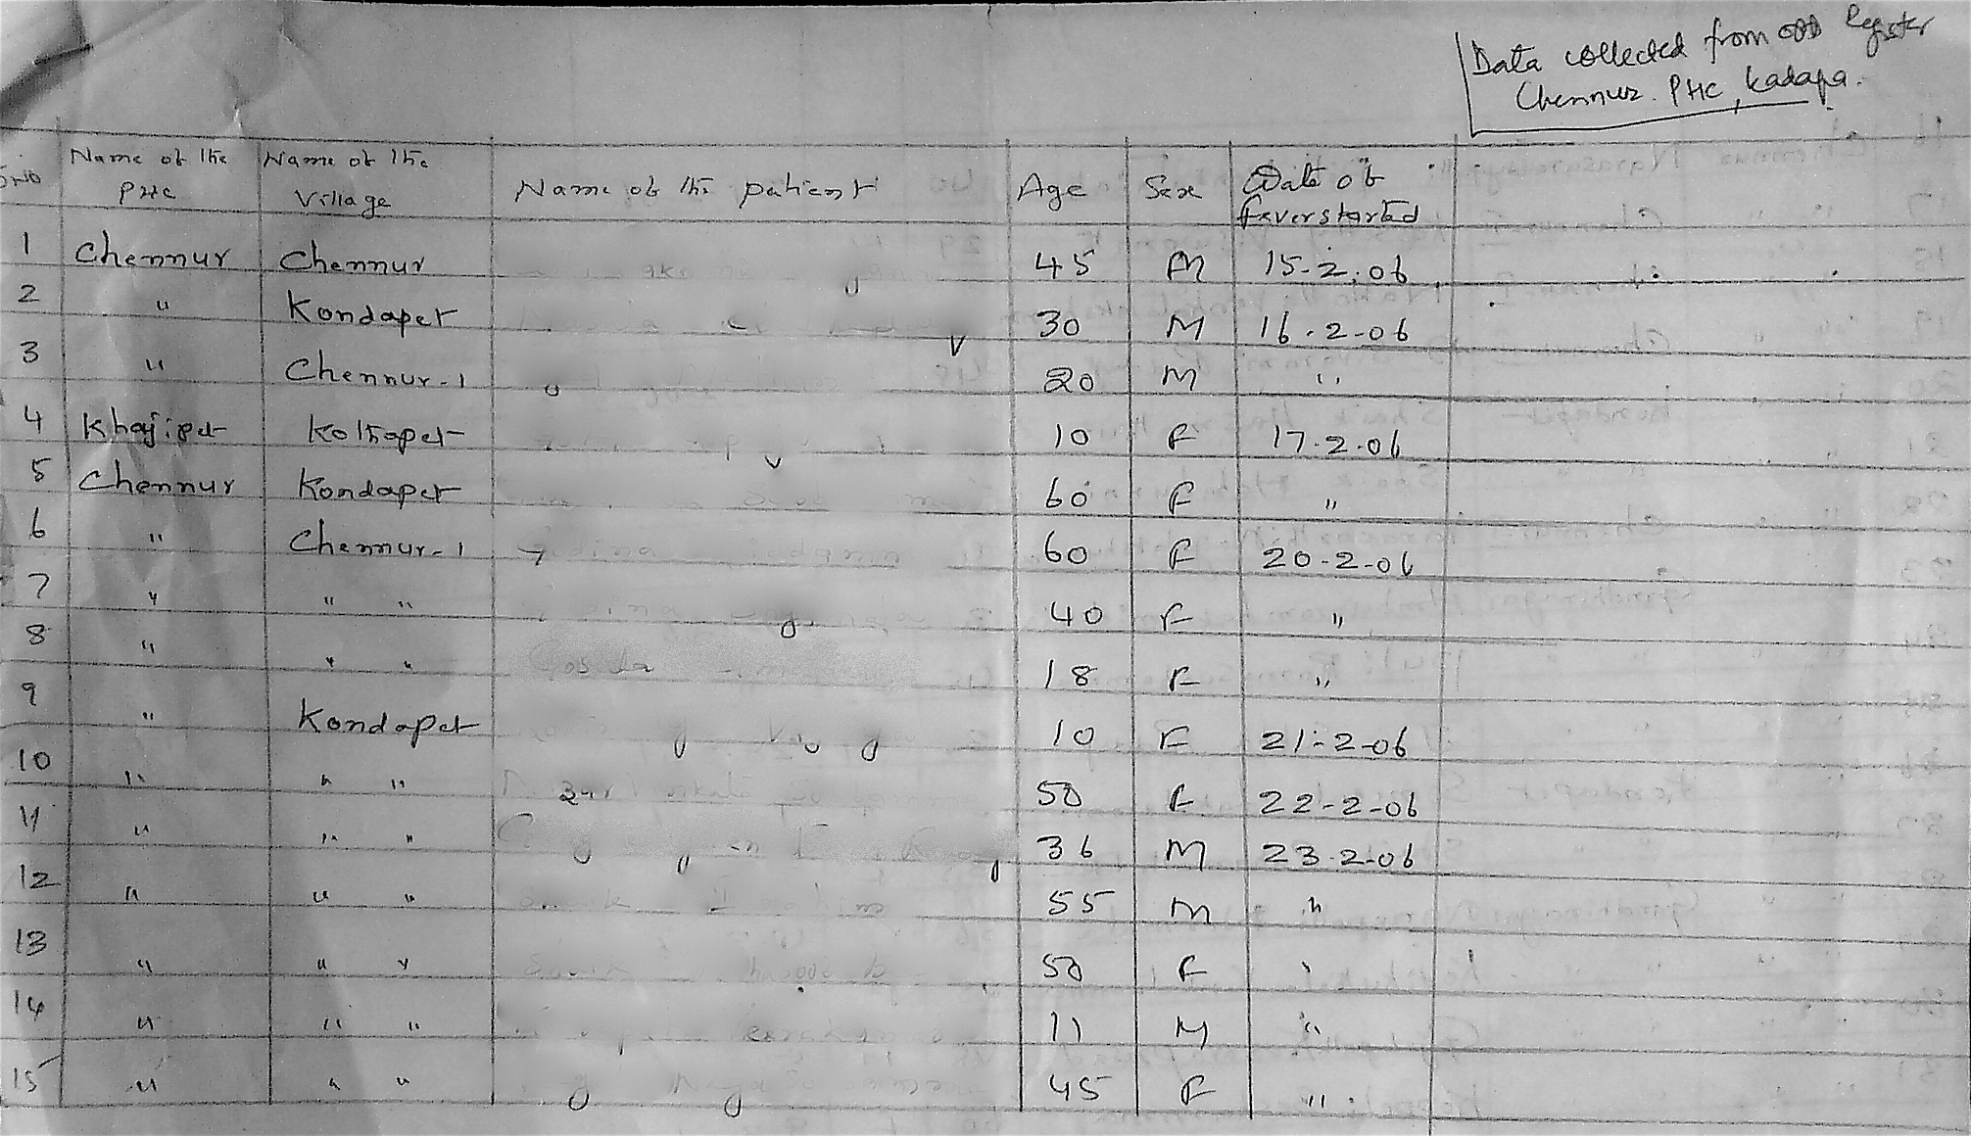

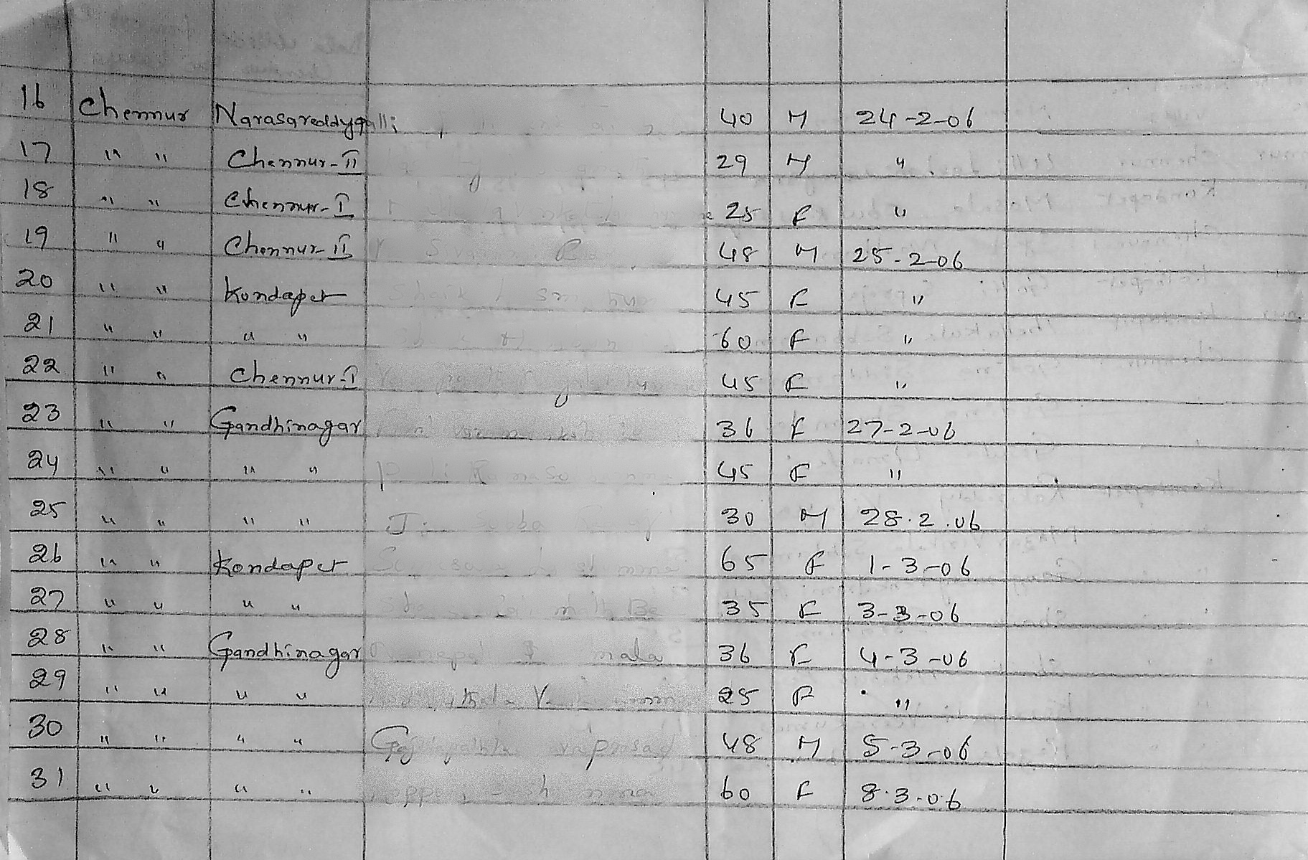

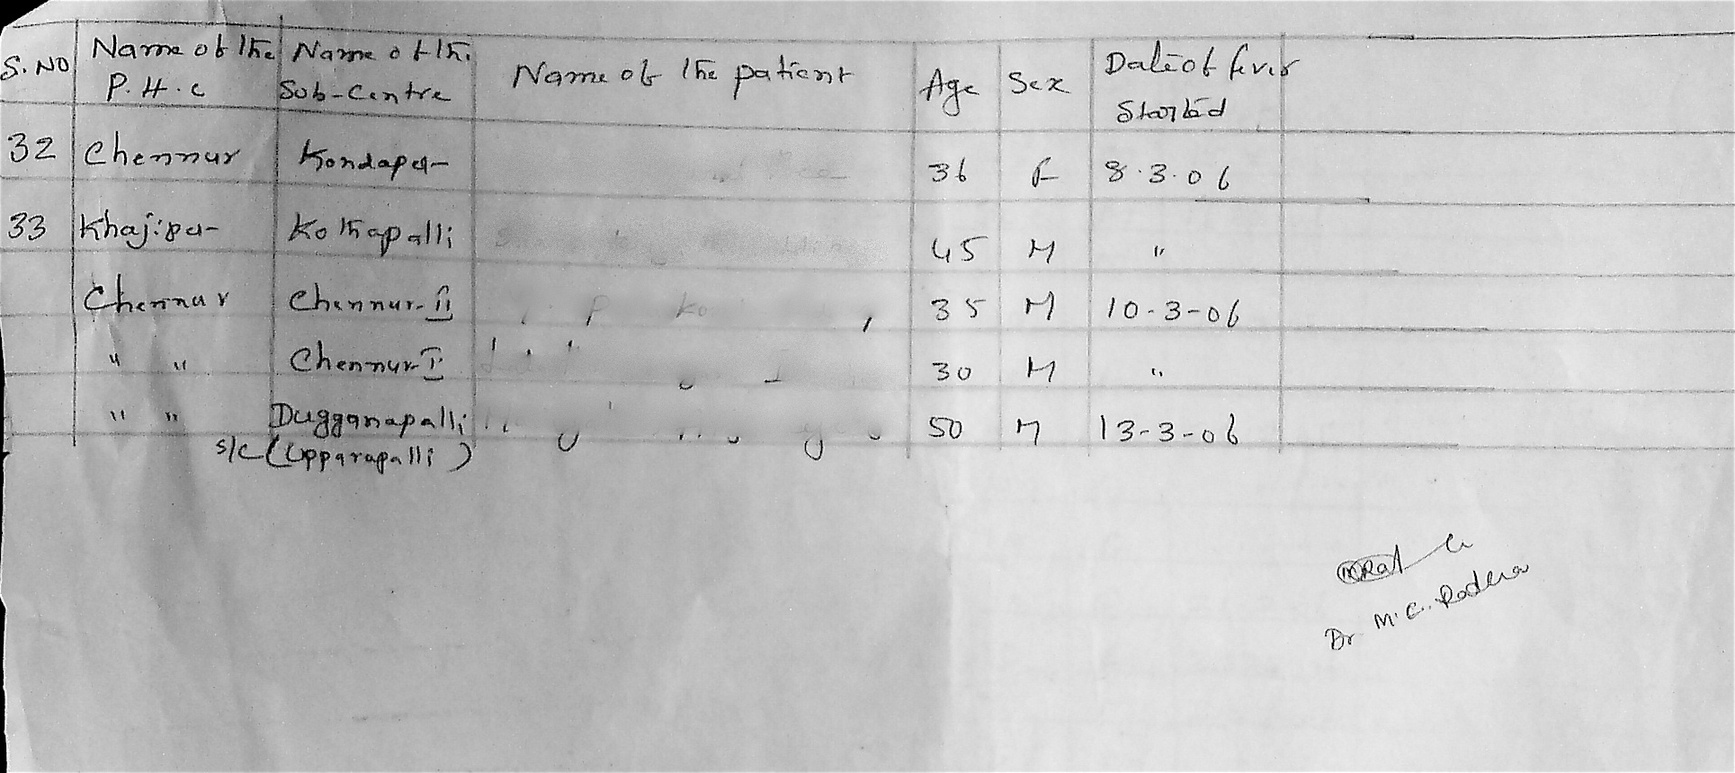

Part 3: Reporting back (2 hours, computer practical)
At this stage, you should have a map of incidence by mandal for the district of Kadapa. In addition, for the primary health centre of Chennur, you should have an epidemic curve and a table of incidence by age and sex. All these should be ready in hardcopies prepared by hand.

Questions
- How can you describe the results of the analysis?
- How would you interpret the results?

Proposed tasks

Report
Working as group, use a word processing software to write a one-page summary (maximum length) of your findings, with the following headings: Introduction, methods, results, conclusions and recommendations. Do no use a font under 12 points. Use bullet format to be brief. Use a portrait format.

Appendices
Add three appendices prepared also in the computer: (1) the map of incidence by mandal, (2) the table of incidence by age and sex and (3) the epidemic curve. Each of these needs to be on one full page, in landscape format.

Part 4: Review (2 hours, computer practical)
Print your report in as many copies as there are groups. Share copies of your report with other groups. Gather as a class for the rest of the workshop.

Questions
- What will make a report useful?
- What are the characteristics of a good report?

Proposed tasks
Examine the reports of the other groups. Exchange comments and suggestions. Extract the best part of each group to consolidate one single report.

